Types of RAM:
There are two important memory devices in the RAM family: SRAM and DRAM. The main difference between them is the duration of the data stored. Static RAM (SRAM) retains its contents as long as electrical power is applied to the chip. However, if the power is turned off or lost temporarily, its contents will be lost forever. Dynamic RAM (DRAM), on the other hand, has an extremely short data lifetimeusually less than a quarter of a second. This is true even when power is applied continuously.
In short, SRAM has all the properties of the memory you think of when you hear the word RAM. Compared with that, DRAM sounds kind of useless. What good is a memory device that retains its contents for only a fraction of a second? By itself, such a volatile memory is indeed worthless. However, a simple piece of hardware called a DRAM controller can be used to make DRAM behave more like SRAM.The job of the DRAM controller, often included within the processor, is to periodically refresh the data stored in the DRAM. By refreshing the data several times a second, the DRAM controller keeps the contents of memory alive for as long as they are needed. So, DRAM is as useful as SRAM after all.
When deciding which type of RAM to use, a system designer must consider access time and cost. SRAM devices offer extremely fast access times (approximately four times faster than DRAM) but are much more expensive to produce. Generally, SRAM is used only where access speed is crucial. However, if a system requires only a small amount of memory, SRAM may make more sense because you could avoid the cost of a DRAM controller.
A much lower cost-per-byte makes DRAM attractive whenever large amounts of RAM are required. DRAM is also available in much larger capacities than SRAM. Many embedded systems include both types: a small block of SRAM (a few hundred kilobytes) along a critical data path and a much larger block of DRAM (in the megabytes) for everything else. Some small embedded systems get by without any added memory: they use only the microcontroller's on-chip memory.
Random-Access Memory (RAM)

• Key features
– RAM is packaged as a chip.

– Basic storage unit is a cell (one bit per cell).

– Multiple RAM chips form a memory.

– It is possible to both read data from and write data to memory easily and rapidly.

Two additional forms of RAM are as follows

• Static RAM (SRAM)
– Each cell stores bit with inverter, transistor circuit.
– Retains value indefinitely, as long as it is kept powered.
– Relatively insensitive to disturbances such as electrical noise.
– Faster and more expensive than DRAM.
– Access time is about 10 ns
– Used for cache memory

• Dynamic RAM (DRAM)

– Each cell stores bit with a capacitor and transistor.
– Because the capacitors have a natural tendency to discharge, value must be refreshed every 10-100 ms.
– Sensitive to disturbances.
– Slower and cheaper than SRAM.
– Read and write operations are suspended when the refresh cycle is going on, this increases the effective access time to 50ns.
– Used for main memory

Advanced DRAM Organization
• Enhanced DRAM
• Cache DRAM
• Synchronous DRAM
• Rambus DRAM
• Enhanced DRAM

6T SRAM Cell
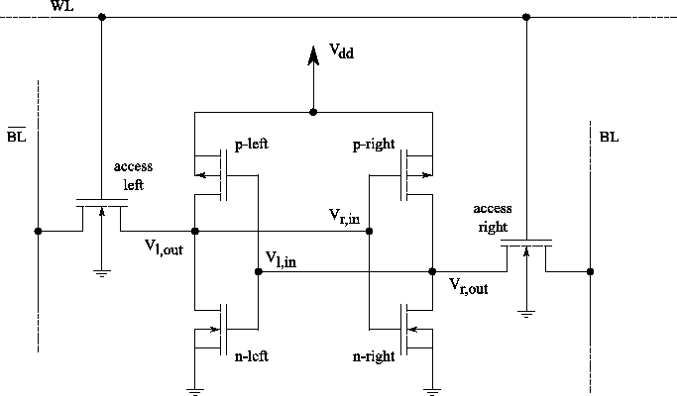
Static random access memory (SRAM) can retain its stored information as long as power is supplied. This is in contrast to dynamic RAM (DRAM) where periodic refreshes are necessary or non-volatile memory where no power needs to be supplied for data retention, as for example flash memory. The term ``random access'' means that in an array of SRAM cells each cell can be read or written in any order, no matter which cell was last accessed.
The structure of a 6 transistor SRAM cell, storing one bit of information, can be seen in Figure. The core of the cell is formed by two CMOS inverters, where the output potential of each inverter 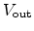 is fed as input into the other . This feedback loop stabilizes the inverters to their respective state.
The access transistors and the word and bit lines, WL and BL, are used to read and write from or to the cell. In standby mode the word line is low, turning the access transistors off. In this state the inverters are in complementary state. When the p-channel MOSFET of the left inverter is turned on, the potential 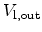 is high and the p-channel MOSFET of inverter two is turned off, 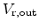 is low.
To write information the data is imposed on the bit line and the inverse data on the inverse bit line, . Then the access transistors are turned on by setting the word line to high. As the driver of the bit lines is much stronger it can assert the inverter transistors. As soon as the information is stored in the inverters, the access transistors can be turned off and the information in the inverter is preserved.
For reading the word line is turned on to activate the access transistors while the information is sensed at the bit lines.
Programmable Logic Devices

Common PLD's include:
o PROM's (I'll use this term generically to include all types of PROM's)

o PLA's - Programmable Array Logic. This technology is obsolete so I will not discuss it.

o PAL Devices - Programmable Array Logic Devices. A very popular device for implementing combinational logic, the type that we've been discussing.

o GAL Devices - Gate Array Logic. Similar to PAL Devices, but these have additional flexibility.
o PGA - Programmable Gate Arrays. These are even more flexible than GAL's.

o FPGA's - Field Programmable Gate Arrays. These devices are very elaborate and can be reprogrammed while being in complete system.

Programmable Logic Devices
Logic devices constitute one of the three important classes of devices used to build digital electronics systems, memory devices and microprocessors being the other two. Memory devices such as ROM and RAM are used to store information such as the software instructions of a program or the contents of a database, and microprocessors execute software instructions to perform a variety of functions, from running a word-processing program to carrying out far more complex tasks.
Logic devices implement almost every other function that the system must perform, including device-to-device interfacing, data timing, control and display operations and so on. So far, we have discussed those logic devices that perform fixed logic functions decided upon at the manufacturing stage. Logic gates, multiplexers, demultiplexers, arithmetic circuits, etc., are some examples. Sequential logic devices such as flip-flops, counters, registers, etc., to be discussed in the following chapters, also belong to this category of logic devices. In the present chapter, we will discuss a new category of logic devices called programmable logic devices (PLDs).
The function to be performed by a programmable logic device is undefined at the time of its manufacture. These devices are programmed by the user to perform a range of functions depending upon the logic capacity and other features offered by the device.
Programmable Logic Devices - An Overview

There are many types of programmable logic device, distinguishable from one another in terms of architecture, logic capacity, programmability and certain other specific features. In this section, we will briefly discuss commonly used PLDs and their salient features. A detailed description of each of them will follow in subsequent sections.

1. Programmable ROMs
PROM (Programmable Read Only Memory) and EPROM (Erasable Programmable Read Only Memory) can be considered to be predecessors to PLDs. The architecture of a programmable ROM allows the user to hardware-implement an arbitrary combinational function of a given number of inputs. When used as a memory device, n inputs of the ROM (called address lines in this case) and m outputs (called data lines) can be used to store 2n m-bit words.
When used as a PLD, it can be used to implement m different combinational functions, with each function being a chosen function of n variables. Any conceivable n-variable Boolean function can be made to appear at any of the m output lines. A generalized ROM device with n inputs and m outputs has 2n hard-wired AND gates at the input and m programmable OR gates at the output. Each AND gate has n inputs, and each OR gate has 2n inputs. Thus, each OR gate can be used to generate any conceivable Boolean function of n variables, and this generalized ROM can be used to produce m arbitrary n-variable Boolean functions.
The AND array produces all possible minterms of a given number of input variables, and the programmable OR array allows only the desired minterms to appear at their inputs. Figure shows the internal architecture of a PROM having four input lines, a hard-wired array of 16 AND gates and a programmable array of four OR gates.
A cross (×) indicates an intact (or unprogrammed) fusible link or interconnection, and a dot (•) indicates a hard-wired interconnection. PROMs, EPROMs and EEPROMs (Electrically Erasable Programmable Read Only Memory) can be programmed using standard PROM programmers. One of the major disadvantages of PROMs is their inefficient use of logic capacity. It is not economical to use PROMs for all those applications where only a few minterms are needed.
Other disadvantages include relatively higher power consumption and an inability to provide safe covers for asynchronous logic transitions. They are usually much slower than the dedicated logic circuits. Also, they cannot be used to implement sequential logic owing to the absence of flip-flops.

2. Programmable Logic Array
A programmable logic array (PLA) device has a programmable AND array at the input and a programmable OR array at the output, which makes it one of the most versatile PLDs. Its architecture differs from that of a PROM in the following respects. It has a programmable AND array rather than a hard-wired AND array. The number of AND gates in an m-input PROM is always equal to 2m . In the case of a PLA, the number of AND gates in the programmable AND array for m input variables is usually much less than 2m , and the number of inputs of each of the OR gates equals the number of AND gates. Each OR gate can generate an arbitrary Boolean function with a maximum of minterms equal to the number of AND gates. Figure 9.4 shows the internal architecture of a PLA device with four input lines, a programmable array of eight AND gates at the input and a programmable array of two OR gates at the output. A PLA device makes more efficient use of logic capacity than a PROM. However, it has its own disadvantages resulting from two sets of programmable fuses, which makes it relatively more difficult to manufacture, program and test.
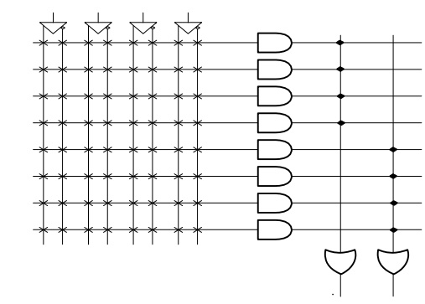
GAL device can be erased and reprogrammed. Also, it has reprogrammable output logic. This feature makes it particularly attractive at the device prototyping stage, as any bugs in the logic can be corrected by reprogramming. A similar device called PEEL (Programmable Electrically Erasable Logic) was introduced by the International CMOS Technology (ICT) Corporation.

3. Complex Programmable Logic Device
Programmable logic devices such as PLAs, PALs, GALs and other PAL-like devices are often grouped into a single category called simple programmable logic devices (SPLDs) to distinguish them from the ones that are far more complex.
A complex programmable logic device (CPLD), as the name suggests, is a much more complex device than any of the programmable logic devices discussed so far. A CPLD may contain circuitry equivalent to that of several PAL devices linked to each other by programmable interconnections. Figure shows the internal structure of a typical CPLD. Each of the four logic blocks is equivalent to a PLD such as a PAL device.
The number of logic blocks in a CPLD could be more or less than four. Each of the logic blocks has programmable interconnections. A switch matrix is used for logic block to logic block interconnections. Also, the switch matrix in a CPLD may or may not be fully connected. That is, some of the possible connections between logic block outputs and inputs may not be supported by a given CPLD.
While the complexity of a typical PAL device may be of the order of a few hundred logic gates, a CPLD may have a complexity equivalent to tens of thousands of logic gates. When compared with FPGAs, CPLDs offer predictable timing characteristics owing to their less flexible internal architecture and are thus ideal for critical control applications and other applications where a high performance level is required. Also, because of their relatively much lower power consumption and lower cost, CPLDs are an ideal solution for battery-operated portable applications such as mobile phones, digital assistants and so on.
A CPLD can be programmed either by using a PAL programmer or by feeding it with a serial data stream from a PC after soldering it on the PC board. A circuit on the CPLD decodes the data stream and configures it to perform the intended logic function.

4. Field-Programmable Gate Array
A field-programmable gate array (FPGA) uses an array of logic blocks, which can be configured by the user. The term ‘field-programmable’ here signifies that the device is programmable outside the factory where it is manufactured. The internal architecture of an FPGA device has three main parts, namely the array of logic blocks, the programmable interconnects and the I/O blocks.
Figure shows the architecture of a typical FPGA. Each of the I/O blocks provides an individually selectable input, output or bidirectional access to one of the general-purpose I/O pins on the FPGA package. The logic blocks in an FPGA are no more complex than a couple of logic gates or a look-up table feeding a flip-flop. The programmable interconnects connect logic blocks to logic blocks and also I/O blocks to logic blocks.
FPGAs offer a much higher logic density and much larger performance features compared with CPLDs. Some of the contemporary FPGA devices offer a logic complexity equivalent to that of eight million system gates. Also, these devices offer features such as built-in hard-wired processors,
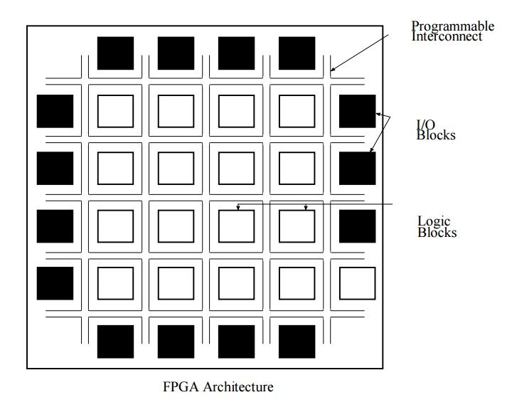
large memory, clock management systems and support for many of the contemporary device-to- device signalling technologies. FPGAs find extensive use in a variety of applications, which include data processing and storage, digital signal processing, instrumentation and telecommunications

