In electrical drives feedback loops or closed loop control satisfy the following requirements.
1. Protection
2. Enhancement of speed of response
3. To improve steady-state accuracy
a) Current Limit Control:
During the starting, we know if precautionary measures are not taken there is a chance of huge current flow through the motor circuit. To limit the current and sense the current fed to the motor, current limit controller is installed. The feedback loop does not effect the normal operation of the drive but if the current exceeds the predetermined safe limit, the feedback loop activates and the current is brought down below the safe limit. Once the current is brought down below the safe limit the feedback loop again deactivates and in this way the control of current takes place.
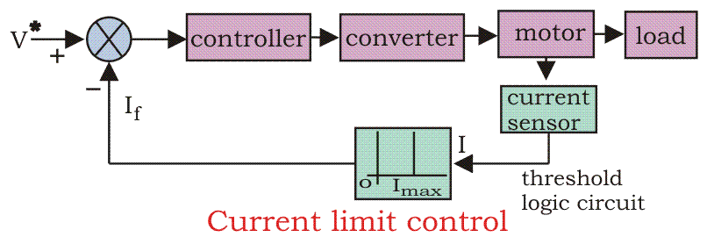

b) Closed Loop Speed Control:
Speed control loops are perhaps the most widely used feedback loops for drives.
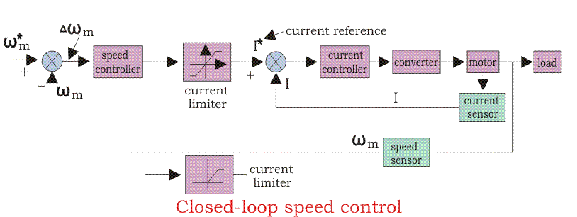
The inner current control loop limits the converter and motor current or motor torque below the safe limit. Suppose the reference speed W_{m}* increases and there is a positive error ΔW_{m}, which indicates that the speed is needed to be increased.
Now the inner loop increases the current keeping it under maximum allowable current. And then the driver accelerates, when the speed reaches the desired speed then the motor torque is equal to the load torque and there is a decrease in the reference speed W_{m} which indicates that there is no need of any more acceleration but there must be deceleration, and braking is done by the speed controller at maximum allowable current.
So, we can say that during speed controlling the function transfers from motoring to braking and from braking to motoring continuously for the smooth operation and running of the motor.

c) Block diagram of closed loop control with current and speed loops
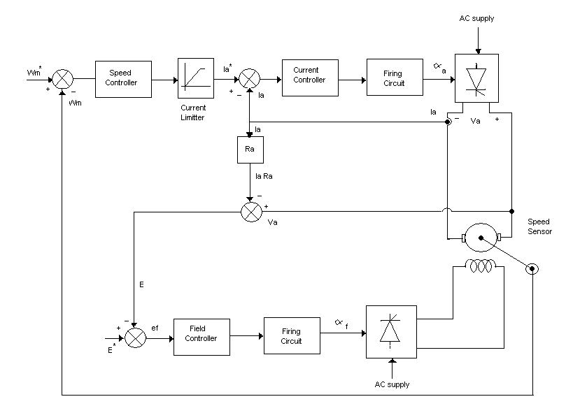
The above diagram shows the closed loop control with inner current loop control and outer speed control loop. The converters are made up of semiconductor materials, which have low thermal capacity. DC motor can carry 2 to 3 times of rated current. Converter and motor is chosen with equal current to allow the maximum permissible rated current.  Basic approach for the closed loop control is above and below the base speed. The field current is constant and armature voltage is variable for below the base speed and for above base speed field current is variable and armature current is constant. The emf is chosen as 0.85 or 0.95 of the rated armature voltage. The speed will vary and it will be compared with reference speed and then speed will be increased according to reference speed.

