UNIT:1
- Mention the advantages of integrated circuits.
- Miniaturization and hence increased equipment density.
- Cost reduction due to batch processing.
- Increased system reliability due to the elimination of soldered joints.
- Improved functional performance.
- Matched devices.
- Increased operating speeds
- Reduction in power consumption
- Define an operational amplifier.
An operational amplifier is a direct-coupled, high gain amplifier consisting of one or more differential amplifier. By properly selecting the external components, it can be used to perform a variety of mathematical operations.
- Mention the characteristics of an ideal op-amp.
➢ Open loop voltage gain is infinity.
➢ Input impedance is infinity.
➢ Output impedance is zero.
➢ Bandwidth is infinity.
➢ Zero offset.
- Define input offset voltage.
A small voltage applied to the input terminals to make the output voltages zero when the two input terminals are grounded is called input offset voltage.
- Define input offset current. State the reasons for the offset currents at the input of the op-amp.
The difference between the bias currents at the input terminals of the op-amp is called as input off set current. The input terminals conduct a s mall value of dc current to bias the input transistors. Since the input transistors cannot be made identical, there exists a difference in bias currents.
- Define CMRR of an op-amp.
The relative sensitivity of an op-amp to a difference signal as compared to a common –mode signal is called the common –mode rejection ratio. It is expressed in decibels.
CMRR= Ad/Ac
- What is supply voltage rejection ration?
SVRR is the ratio of the change in the input offset voltage to the corresponding change in power supply voltages. This is expressed in ΔV / V or in decibels, SVRR can be defined as
SVRR =ΔVio / ΔV
Where ΔV is the change in the input supply voltage and ΔVio is the corresponding change in the offset voltage.For the 741C, SVRR = 150 μ V / V.
- In practical op-amps, what is the effect of high frequency on its performance?
The open-loop gain of op-amp decreases at higher frequencies due to the presence of parasitic capacitance. The closed-loop gain increases at higher frequencies and leads to instability.
- What is the need for frequency compensation in practical op-amps? Mention the frequency compensation methods?
Frequency compensation is needed when large bandwidth and lower closed loop gain is desired. Compensating networks are used to control the phase shift and hence to improve the stability. The frequency compensation methods are:
- Dominant-pole compensation
- Pole-zero compensation.
- What are the merits and demerits of Dominant-pole compensation?
➢ Noise immunity of the system is improved.
➢ Open-loop bandwidth is reduced.
- Define slew rate. What causes slew rate?
The slew rate is defined as the maximum rate of change of output voltage caused by a step input voltage. An ideal slew rate is infinite which means that op-amp’s output voltage should change instantaneously in response to input step voltage. There is a capacitor with-in or outside of an op-amp to prevent oscillation. It is this capacitor which prevents the output voltage from responding immediately to a fast changing input.

- Why IC 741 is not used for high frequency applications?
IC741 has a low slew rate because of the predominance of capacitance present in the circuit at higher frequencies. As frequency increases the output gets distorted due to limited slew rate.
- Draw the pin diagram of 741 IC op-amp and list out its features?
- No External frequency compensation is required

- Short circuit Protection

- Off Set Null Capability

- Large Common mode and differential Voltage ranges

- Low Power Dissipation

- No-Latch up Problem

- 7.741 is available in three packages:- 8-pin metal can, 10-pin flat pack and 8 or 14-pin DIP.
- 741 series models are 741,741A, 741C and 741E.

- 741C operate on two temperatures 25 degree for room temperature and 0-70 degree for commercial

- It is monolithic IC fabricated

- Applications are integrator, summer, voltage follower and other feedback applications

- For 741 IC, SVRR = 150uV/V.

- The output voltage swing of the 741 IC is a 26 volt peak-to-peak

- Typial values of output resistance of 741 IC are 75ohms.

- The value for 741 IC may go as high as 2megaohms.

- For a 741 IC, typical value of voltage is ±15mV

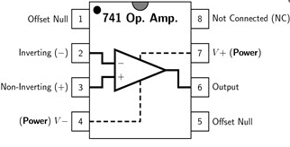

- Compare Ideal And Practical Characteristics Of Op-Amp?

CHARACTERISTICS | IDEAL | PRACTICAL
Open loop gain | INFINITY | 10^6
INPUT RESISTANCE | INFINITY | 1 m ohms -2m ohms
OUTPUT RESISTANCE | 0 | 50ohms-100 ohms
OPEN LOOP BANDWIDTH | INFINITY | 1MHz
OFFSET VOLTAGE | 0 | < 10 mV
OFFSET CURRENT | 0 | 10nA
CMMR | INFINITY | 90dB
SLEW RATE | INFINITY | 1V/sec

- Define the closed loop configuration Voltage Follower (Unity Gain Buffer)?

As the input signal is connected directly to the non-inverting input of the amplifier the output signal is not inverted resulting in the output voltage being equal to the input voltage, Vout = Vin. This then makes the voltage follower circuit ideal as a Unity Gain Buffer circuit because of its isolation properties as impedance or circuit isolation is more important than amplification while maintaining the signal voltage.

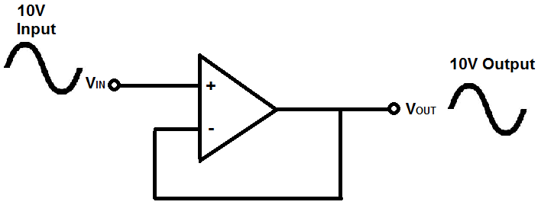
- Draw non-inverting amplifier configuration with feedback and derive its gain ?

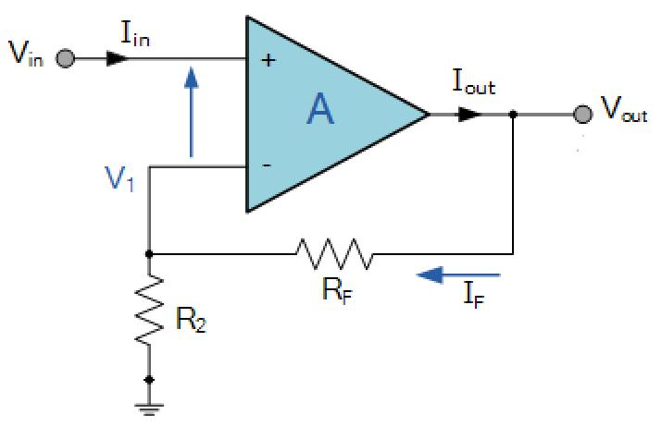

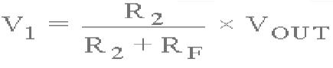

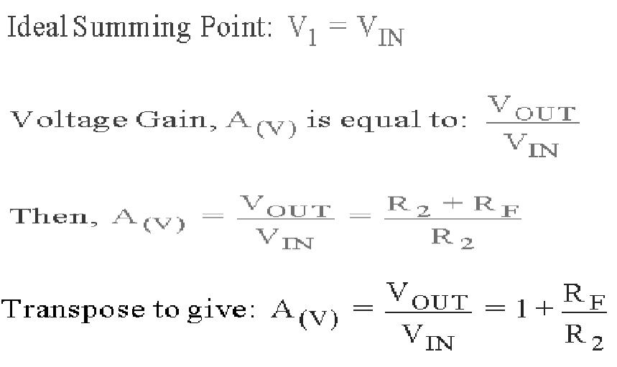

- Draw inverting amplifier configuration with feedback and derive its gain?
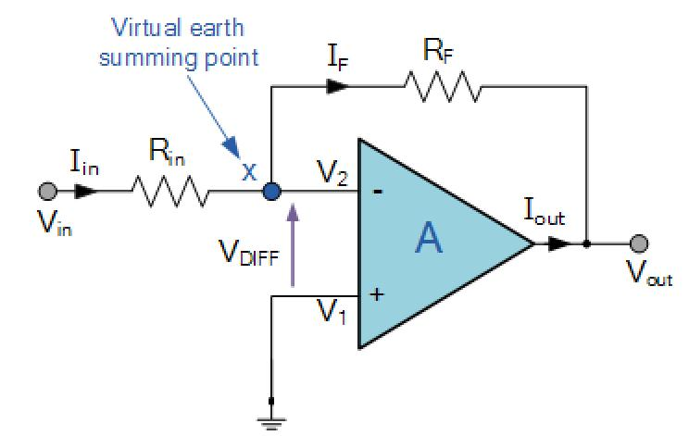

.

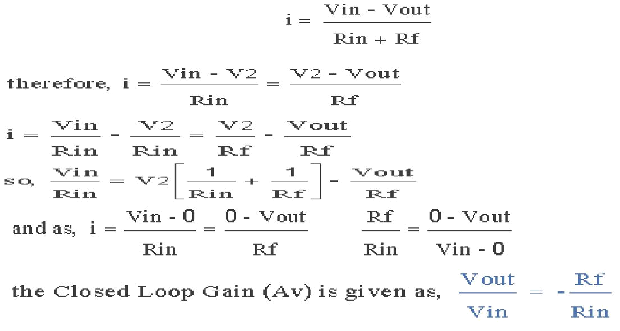

18.Draw and Explain the internal block diagram of op-amp ckt.

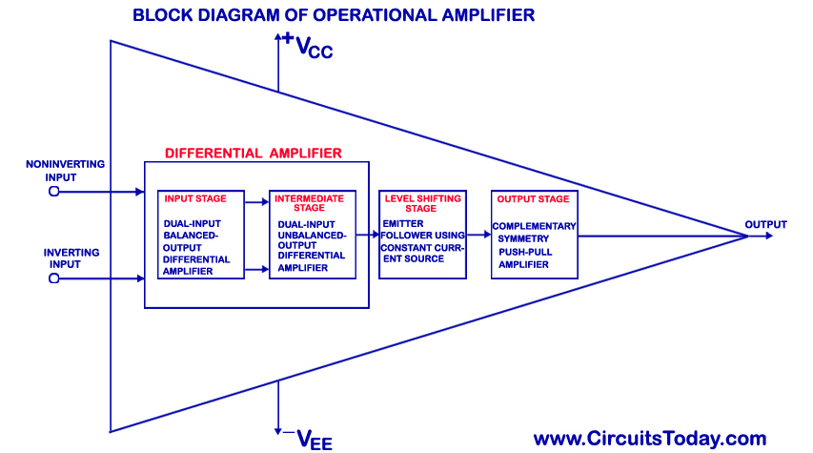
Input stage:-This stage provides ost of the voltage gain of the amplifier and establishes the input resistance of the op-amp.
Intermediate Stage:-It is another differential amplifier which is driven by output of first stage. It is dual input, unbalanced (single ended)output.
Level shifting stage:-Because direct coupling is used,the dc voltage at the output of the intermediate stage is well above the ground potential,\.Therefore level translator(shifting) ckt.is used after intermediate stage to shift the dc level to zero volts with respet to ground.
Output stage:-Output stage increases the output voltage swing and raises the current supplying capability of the op-amp.
19.What is differentiator?
- A differentiator is the circuit which perform the mathematical operation of differentiation i.e the output waveform is the derivative of the input waveform.

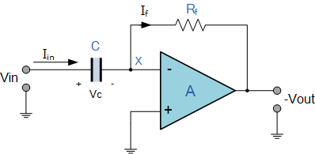
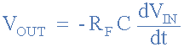
20. What are the main drawback of ideal differentiator?
- The main drawback of ideal differentiator are: At high frequency the differentiator becomes unstable and break into oscillation.The input impedance decreases with the increase in frequency there by making the circuit sensitive to high frequency noise.

- Mention the main application of differentiator?
The main application of differentiator are:
- Used in wave shaping circuits to detect high frequency components in an input signal
- Used as rate of change detector in FM modulations

- What is an integrator circuit? how it is obtained?
An Op-amp circuit that produces an output signal, which is an integral of input signal, is called as integrator circuit. It is obtained by simply interchanging resistor and capacitor of differentiator circuit.
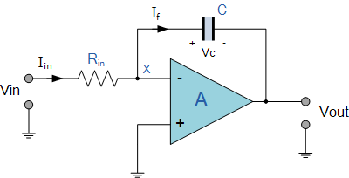
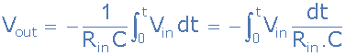
- List out the drawbacks of ideal integrator?
The drawbacks of ideal inegrator are: At low frequency gain becomes infinity,When the op amp saturates i,e the capacitor is fully charged it behaves like an open circuit.
- Why is the practical integrator called as lossy integartor?
The gain of the integrator at lower frequencies can be limited to avoid the saturation problem, if the feedback capacitor C_{f} is shunted by feedback resistor R_{f}. The parallel combination of R_{f} and C_{f} behaves like practical capacitor which dissipates power unlike an ideal capacitor. For this reason the circuit is called as lossy integrator.
- List any four applications of practical integrator?
The applications of practical integrator are: Analog computer, analog to digital computers, wave shaping and in ramp generators.
- What are the limitations of an ideal active differentiator?
At high frequency, differentiators may become unstable and break into oscillation. The input impedance i.e. (1/ωC1) decreases with increase in frequency, thereby making the circuit sensitive to high frequency noise.

UNIT:2

- Mention some of the linear applications of op – amps.?
- Adder, subtractor, voltage-current converter, current-voltage converters, instrumentation amplifier, analog computation, power amplifier, etc are some of the linear op-amp circuits.
- What is the need for an instrumentation amplifier?
- In a number of industrial and consumer applications, the measurement of physical quantities is usually done with the help of transducers. The output of transducer has to be amplified So that it can drive the indicator or display system. This function is performed by an instrumentation amplifier.
- List the features of instrumentation amplifier?
- High gain accuracy, high CMRR,high gain stability with low temperature co-efficient, low dc offset, low output impedance.
4.What are the applications of instrumentation amplifier?
The instrumentation amplifier along with a transducer bridge can be used in a wide variety of applications
- Temperature controller
- Temperature indicator
- Light Intensity meter.
5.What are the advantages and disadvantages of instrumentation amplifier?
Advantages
(1)Accurate testing and measurement
(2)Stable and easy to use
(3)Reliability of setup and results.
(4)Highly scalable.
Disadvantages
(1)Long range transmission Issues.

- What are the applications of V-I converter?
➢ Low voltage dc and ac voltmeter, L E D and Zener diode tester.
- What is an antilog amplifier? Draw the circuit of an antilog amplifier.
Antilog amplifier is a decoding circuit to convert a logarithmically encoded signal back to the real signal.
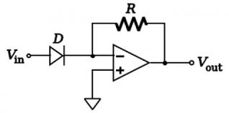
The current equation of diode is given as I_{d} = I_{do}*(exp (V/V_{t})-1)
applying KCL at inverting node of opamp we get
I_{d} = (0-V_{o})/R = I_{o}*(exp (V_{in}/V_{t})) (assumed V_{in} /V_{t} >> 1)
Hence V_{o} = -I_{o}*R*(exp (V_{in}/V_{t})).
Gain of Anti log amplifier K= -Io*R

- Draw the circuit of an log amplifier derive its equation?
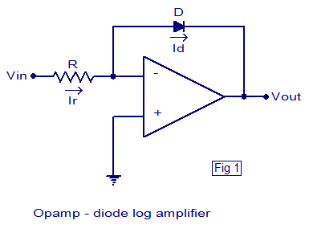
The current equation of diode is given as I_{d} = I_{do}*(exp (V/V_{t})-1)
applying KCL at inverting terminal of opamp, we get
(0-V_{in})/R₁ + I_{d} = 0 implies I_{d} = V_{in}/R₁
Substituting the equation for current in the above equation we get I_{do}*(exp (V/V_{t})-1) = V_{in}/R₁. Assuming exp (V/V_{t}) >> 1 i.e. V>>V_{t} and V = – V_{o}, we get I_{do}*exp (-V_{o} / V_{t}) = V_{in}/R₁. Applying Antilog on both sides we get
V_{o} = – V_{t} * ln (V_{in}/(R₁*I_{do})).

- Draw the circuit of summing amplifier and writes its output voltage?
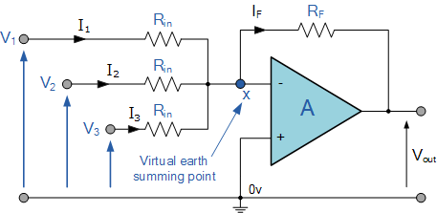

10. Draw the circuit of difference amplifier and write its output voltage?

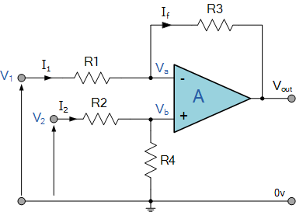
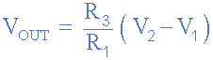
11. List the application of log amplifiers?
- Analog computations like logx, sinhx etc
- Log amplifier can perform direct db display on digital voltmeter and spectrum analyzer
- Log amplifier can be used to compress the dynamic range of a signal
12. Draw differential amplifier using op amp and writes its overall gain equation?
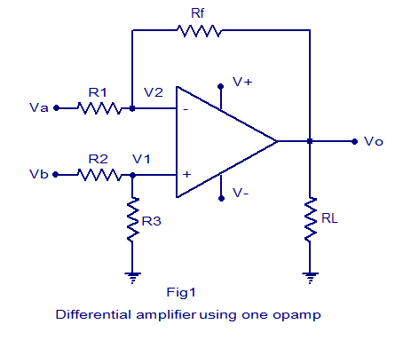
Therefore overall gain is 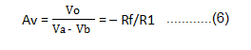

- What do you mean by a precision diode? Write down the applications of precision diode?
The major limitation of ordinary diode is that it cannot rectify voltages below the cut – in voltage of the diode. A circuit designed by placing a diode in the feedback loop of an op – amp is called the precision diode and it is capable of rectifying input signals of the order of millivolt. The applications are
➢ Half - wave rectifier
➢ Full - Wave rectifier
➢ Peak – value detector
➢ Clipper
➢Clamper
- What is a comparator? What are the applications of comparator?
A comparator is a circuit which compares a signal voltage applied at one input of an op-amp with a known reference voltage at the other input. It is an open loop op -amp with output +Vsat .The applications are
➢ Zero crossing detector
➢ Window detector
➢ Time marker generator
➢ Phase detector
- What is a Schmitt trigger?
Schmitt trigger is a regenerative comparator. It converts sinusoidal input into a square wave output. The output of Schmitt trigger swings between upper and lower threshold voltages, which are the reference voltages of the input waveform.
16.What is multivibrator?
Multivibrators are a groupregenerative circuits that are used in timing applications.It is a wave shaping circuitwhich gives symmetric or asymmetric square output.It has two states either stable or quasi-stable depending on the type of multivibrator.
17.What do you mean by Monostable Multivibrator?
Monostable Multivibratoris one which generates a single pulse of specified duration in response to each external trigger signal.It has only one stable state .Application of trigger causes a change to the quasi-stable state.An external trigger signal generated due to charging and discharging of the capacitor produces the transition to the original stable state.
18.What is an Astable Multivibrator?
Astable Multivibrator is a free running oscillator having two quasi-stable states.Thus,there are oscillations between these two states and no external signal is required to produce the change in state.
19.What is bi-stable multivibrator?
Bistable multivibrators have two stable states and maintain a given output state indefinitely unless an external trigger is applied forcing it to change state.
20.Write the applications of peak detector.
Peak detector find application in test and measurement instrumentation as well as in amplitude modulation(AM) communication.
21. Define clippers with a neat diagram and waveform?
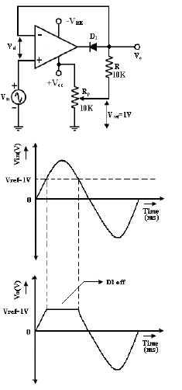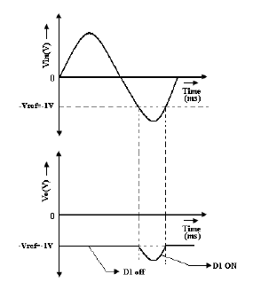
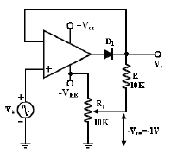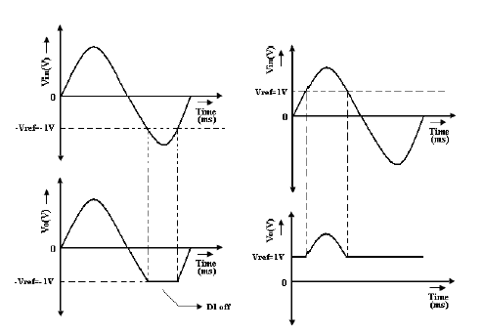

22.Draw the circuit of clampers and its waveform?


