Logic diagram and logic equation of AND gate
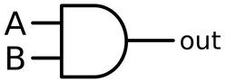
Y(A and B) = A.B

Logic diagram and logic equation of NAND gate
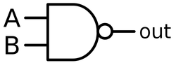
Y (A nand B) = = A|B =

Logic diagram and logic equation of OR gate
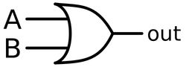
Y (A or B) = A + B

Logic diagram and logic equation of NOR gate
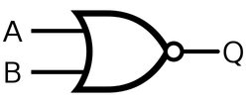
Y (A nor B) = =

Logic diagram and logic equation of NOT gate
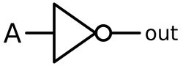
Y (not A) = A’ =

Logic diagram and logic equation of XOR gate
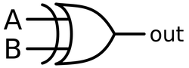
Y (A exor B) = A B = AB’ + A’B

Logic diagram and logic equation of XNOR gate
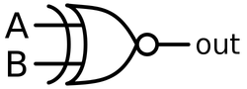
Y (A exnor B) = = A’B’ + AB

VHDL code for all logic gates using dataflow method
library IEEE;

use IEEE.STD_LOGIC_1164.ALL;

use IEEE.STD_LOGIC_ARITH.ALL;

use IEEE.STD_LOGIC_UNSIGNED.ALL;

entity ALLGATES_SOURCE is

Port ( A,B : in STD_LOGIC;

P, Q, R, S, T, U, V : out STD_LOGIC);

end ALLGATES_SOURCE;

architecture dataflow of ALLGATES_SOURCE is

begin

--- you have to remember the commands for boolean logic in VHDL as shown below

P < = A and B;

Q < = A nand B;

R <= A or B;

S <= A nor B;

T <= not A;

U <= A xor B;

V <= A xnor B;

end dataflow;

library IEEE;
use IEEE.STD_LOGIC_1164.ALL;

entity and_or_top is
Port ( INA1 : in STD_LOGIC; -- AND gate input
INA2 : in STD_LOGIC; -- AND gate input
OA : out STD_LOGIC; -- AND gate output
end and_or_top;

architecture Behavioral of and_or_top is
begin
OA <= INA1 and INA2; -- 2 input AND gate
end Behavioral;

library IEEE;
use IEEE.STD_LOGIC_1164.ALL;

entity and_or_top is
Port ( INO1 : in STD_LOGIC; -- OR gate input
INO2 : in STD_LOGIC; -- OR gate input
OO : out STD_LOGIC); -- OR gate output
end and_or_top;

architecture Behavioral of and_or_top is
begin
OO <= INO1 or INO2; -- 2 input OR gate
end Behavioral;

VHDL code for Full Adder

The full adder has three inputs X1, X2, Carry-In Cin and two outputs S, Carry-Out Cout as shown in the following figure:
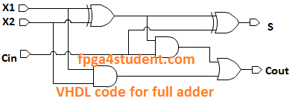

The VHDL code for the full adder using the structural model:
-- fpga4student.com
-- FPGA projects, VHDL projects, Verilog projects
-- VHDL code for full adder
-- Structural code for full adder
library ieee;
use ieee.std_logic_1164.all;
entity Full_Adder_Structural_VHDL is
port(
X1, X2, Cin : in std_logic;
S, Cout : out std_logic
);
end Full_Adder_Structural_VHDL;
architecture structural of Full_Adder_Structural_VHDL is
signal a1, a2, a3: std_logic;
begin
a1 <= X1 xor X2;
a2 <= X1 and X2;
a3 <= a1 and Cin;
Cout <= a2 or a3;
S <= a1 xor Cin;
end structural;

The VHDL code for the full adder using the behavioral model:

library ieee;
use ieee.std_logic_1164.all;

entity fulladder is
port(a:in std_logic_vector(2 downto 0);
s,ca:out std_logic);
end fulladder;

architecture fulladder of fulladder is
begin
process(a)
begin
if a="000" then s<='0';ca<='0';
elsif a="001" then s<='1';ca<='0';
elsif a="010" then s<='1';ca<='0';
elsif a="011" then s<='0';ca<='1';
elsif a="100" then s<='1';ca<='0';
elsif a="101" then s<='0';ca<='1';
elsif a="110" then s<='0';ca<='1';
else s<='1';ca<='1';
end if;
end process;
end fulladder;

DECODER

Truth table for a 2:4 decoder
A | B | Y3 | Y2 | Y1 | Y0
0 | 0 | 0 | 0 | 0 | 1
0 | 1 | 0 | 0 | 1 | 0
1 | 0 | 0 | 1 | 0 | 0
1 | 1 | 1 | 0 | 0 | 0
From this truth table, we get the following logic equations for the outputs.
Y0 = A’B’
Y1 = A’B
Y2 = AB’
Y3 = AB

VHDL code for decoder using dataflow method
2:4 DECODER DATAFLOW
library IEEE;

use IEEE.STD_LOGIC_1164.ALL;

use IEEE.STD_LOGIC_ARITH.ALL;

use IEEE.STD_LOGIC_UNSIGNED.ALL;

entity DECODER_SOURCE is

Port ( A,B : in STD_LOGIC;

Y3,Y2,Y1,Y0 : out STD_LOGIC);

end DECODER_SOURCE;

architecture dataflow of DECODER_SOURCE is

begin

Y0 <= ((not A)and(not B));

Y1 <= ((not A) and B);

Y2 <= (A and (not B));

Y3 <= (A and B);

end dataflow;

flipflops

A Flip-flop is the basic element which is used to store information of one bit. Flip-flops have their content change either at the rising or falling edge of the enable signal(usually the controlling clock signal).
There are basically four main types of flip-flops in VHDL:
1. SR Flip-flop
2. D Flip-flop
3. JK Flip-flop
4. T Flip-flop.

1. SR FLIP-FLOP VHDL Code:
A SR flip flop used in digital electronics will provide the results in a similar manner to the JK flip flop and this is the reason why the vhdl codes for these two flipflops are similar in nature.
Given below is a behavioral approach of writing the VHDL code for a SR Flip-flop.

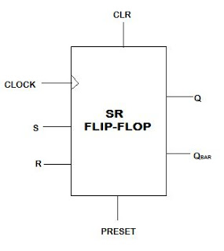
library ieee;
use ieee. std_logic_1164.all;
use ieee. std_logic_arith.all;
use ieee. std_logic_unsigned.all;

entity SR-FF is
PORT( S,R,CLOCK,CLR,PRESET: in std_logic;
Q, QBAR: out std_logic);
end SR-FF;

Architecture behavioral of SR-FF is
begin
P1: PROCESS(CLOCK,CLR,PRESET)
variable x: std_logic;
begin
if(CLR='0') then
x:='0';

elsif(PRESET='0')then
x:='1';

elsif(CLOCK='1' and CLOCK'EVENT) then

if(S='0' and R='0')then
x:=x;
elsif(S='1' and R='1')then
x:='Z';

elsif(S='0' and R='1')then
x:='0';

else
x:='1';

end if;
end if;

Q<=x;
QBAR<=not x;
end PROCESS;
end behavioral;

2. D FLIP-FLOP VHDL Code:
A D flip flop or Delay flip flop gives the same output as the input provided and thus the vhdl code is much simpler.
Given below is a behavioral approach of writing the vhdl code for a D Flip-flop.

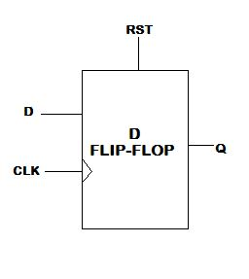

library ieee;
use ieee. std_logic_1164.all;
use ieee. std_logic_arith.all;
use ieee. std_logic_unsigned.all;

entity D-FF is
PORT( D,CLK,RST: in std_logic;
Q: out std_logic);
end D-FF;

architecture behavioral of D-FF is

begin
P1: process(RST,CLK)

begin
if(RST='1')then
Q<='0';
elsif(CLK='1' and CLK'EVENT) then
Q<=D;
end if; end process;
end behavioral;
Best VHDL books online

3. JK FLIP-FLOP VHDL Code:
Given below is a behavioral approach of writing the VHDL code for a JK Flip-flop.
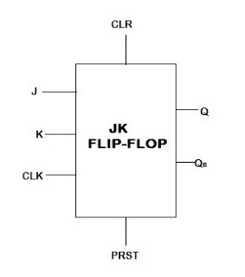

library ieee;
use ieee. std_logic_1164.all;
use ieee. std_logic_arith.all;
use ieee. std_logic_unsigned.all;

entity JK-FF is
PORT( J,K,CLK,PRST,CLR: in std_logic;
Q, QB: out std_logic);
end JK-FF;

Architecture behavioral of JK-FF is
begin
P1: PROCESS(CLK,CLR,PRST)
variable x: std_logic;
begin
if(CLR='0') then
x:='0';

elsif(PRST='0')then
x:='1';

elsif(CLK='1' and CLK'EVENT) then
if(J='0' and K='0')then
x:=x;
elsif(J='1' and K='1')then
x:= not x;

elsif(J='0' and K='1')then
x:='0';
else
x:='1';

end if;
end if;
Q<=x;
QB<=not x;
end PROCESS;
end behavioral;

4. T FLIP-FLOP VHDL Code:

The T in a t flip flop stands for toggle and this is exactly what this digital component does. It simply toggles the value of a particular input. A basic not gate will solve the problem in the vhdl code for this element.

Given below is a behavioral approach of writing the VHDL code for a T Flip-flop.

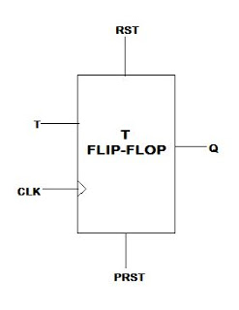

library ieee;
use ieee. std_logic_1164.all;
use ieee. std_logic_arith.all;
use ieee. std_logic_unsigned.all;

entity T-FF is

PORT( T,CLK,PRST,RST: in std_logic;
Q: out std_logic);

end T-FF;

architecture behavioral of T-FF is

begin
P1: process(CLK,PRST,RST)

variable x: std_logic;

begin

if(RST='0') then

x:='0';

elsif(RST='1' and PRST='0') then

x:='1';

elsif(CLK='1' and CLK'EVENT) then

if(T='1')then

x:= not x;

end if;
end if;

Q<=x;

end process;
end behavioral;

